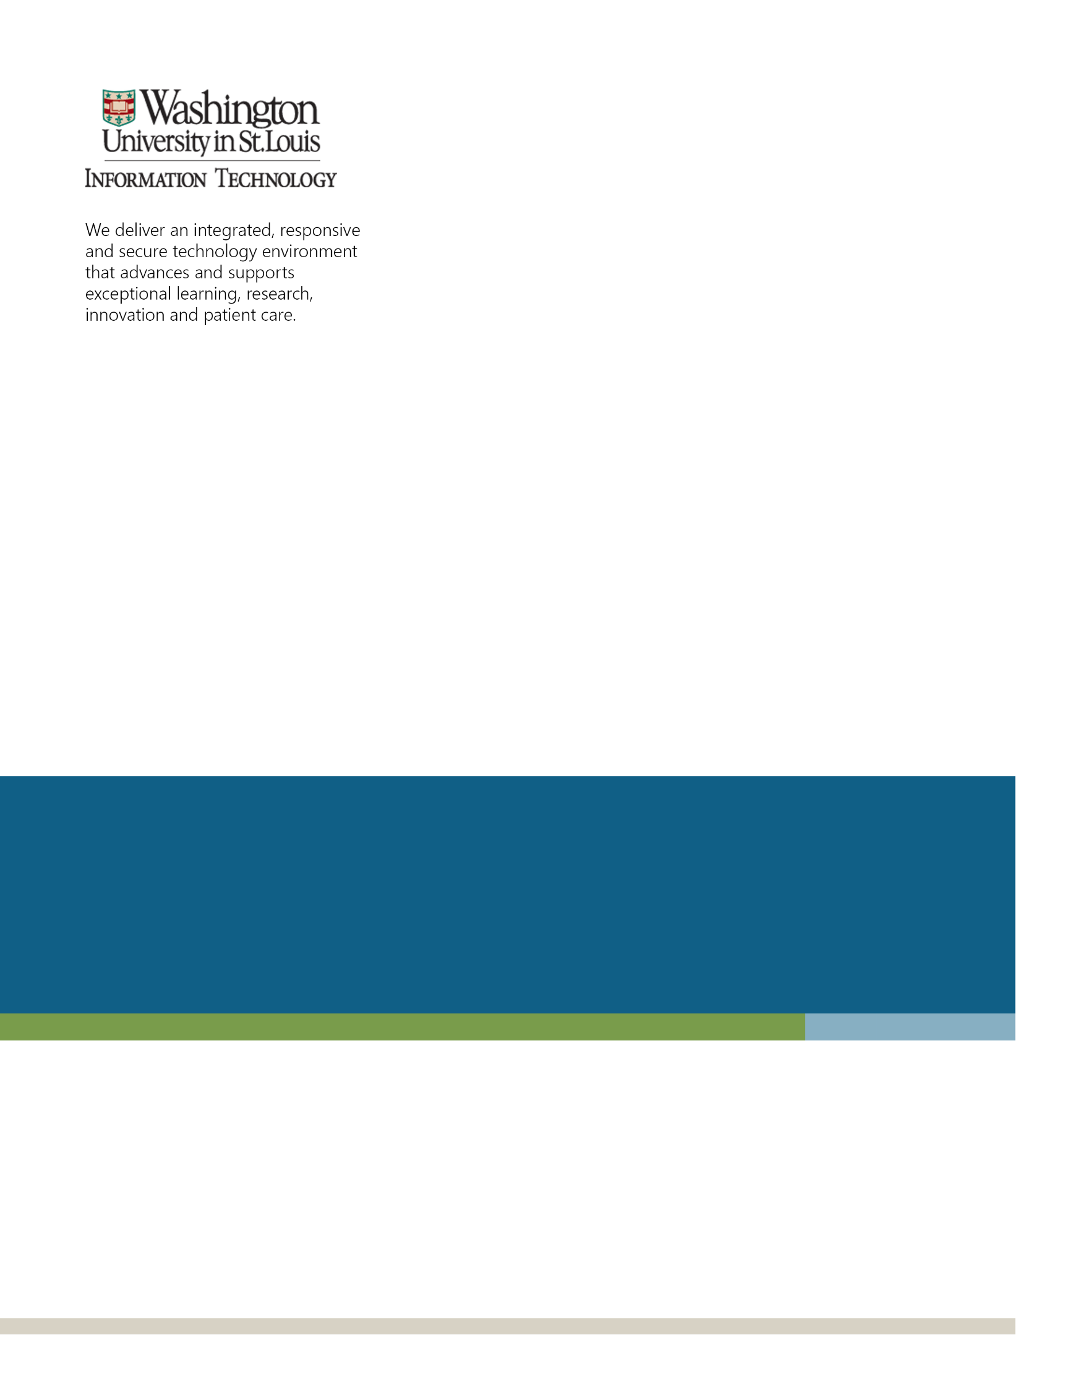

ARCHIBUS
General User Guide
Contents
Access for ARCHIBUS Web Central 4
Logging in 4
Signing off 4
ARCHIBUS Web Central Overview 5
Accessing Views 5
The Process Navigator 6
Select Data Using the Select Value Button 7
Completing Validated Fields 8
Sorting Data 9
Using Filter Controls 10
Restricting Data 10
Restricting Data 11
Using Drill Down Selection Lists 11
Background Information for Room Reservations 12
Help Text for Room Reservations 12
Reserving Rooms and/or Resources 13
Process Navigator for Creating Reservations 13
Create a New Room Reservation 14
Create a New Room Reservation 15
Create a New Room Reservation 16
Create a New Room Reservation 17
Create a New Resource Reservation 18
Create a New Resource Reservation 19
Create a Multi-Room Reservation 20
Create a Multi-Room Reservation 21
Create a Multi-Room Reservation 22
View and Edit My Reservations 23
View and Edit My Reservations 24
View and Edit My Reservations 25
Resolve My Reservation Conflicts 25
Calendar View – Read Only 26
Process Navigator for Managing Reservations 27
Verify a Room Reservation 28
Resolve My Reservation Conflicts 28

Access for ARCHIBUS Web Central

Logging in

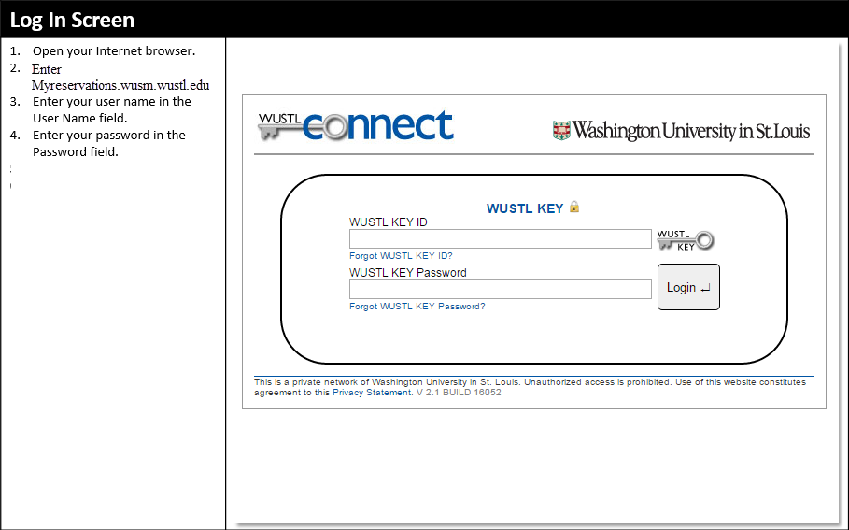

Signing off

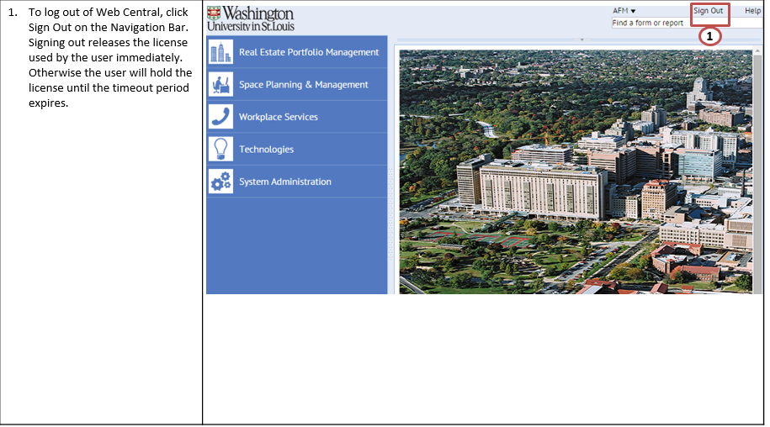

ARCHIBUS Web Central Overview

Accessing Views

ARCHIBUS Web Central organizes facilities and infrastructure management tasks in an intuitive web browser interface. Using ARCHIBUS Web Central, you will access reports, views, business charts, drawings, and other data.
- You can easily navigate to the data using the ARCHIBUS Web Central Process Navigator, which is located in the left frame of the application. The Process Navigator presents tasks, which are grouped by activity and these tasks load ARCHIBUS views.
- The presentation of data you access is known as a view into the data.
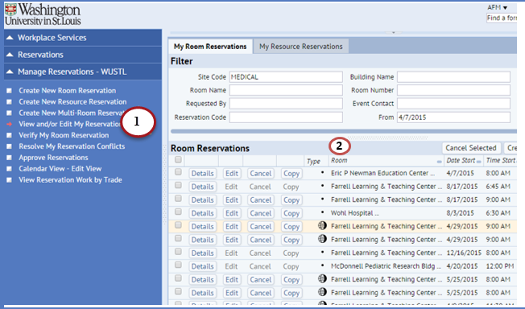

The Process Navigator

The Process Navigator divides Web Central into a series of directed activities, each focused on a specific area of your business. Your business process owner or system administrator has set up for you processes which contain the tasks you need for your particular role. Selecting a task loads the view for that task.
- To access a particular task, click on the activity.
- Click on the process
- Click on the task.
- To return to a previous level of the Process Navigator, click on the up arrow.
Note: If you have only one activity or process the program will select it automatically for you. Clicking on a task loads the view or report you need; this is also known as a view into the data.
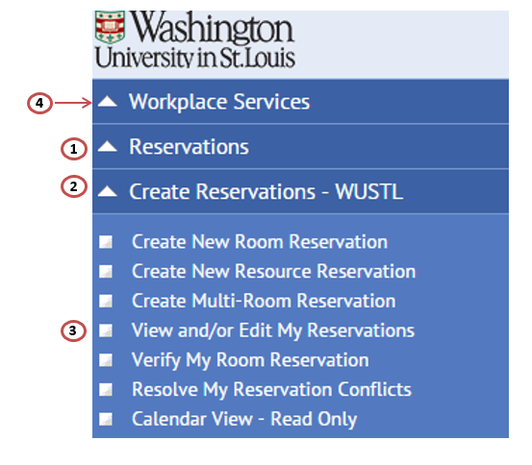

Select Data Using the Select Value Button

Many views include a Select Value list to facilitate entering data.
- When you mouse over or activate a validated field, the system displays the Select Value or ellipses button ( …). Click on the Select Value button.
- Select a value, in this case, a building name by clicking on it.
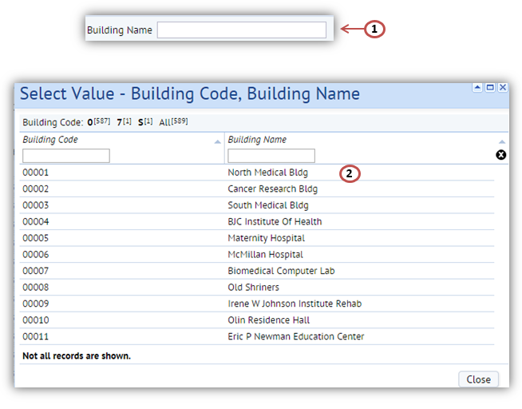

Completing Validated Fields

In a project database, database tables often contain validated fields that are fields that must be completed with values that already exist in another database validating table. Validated fields help maintain data integrity by ensuring that you enter appropriate values for database fields. There are a few ways to complete validated fields:
- Click the Select Values (ellipses) button (as shown on slide 8), and the system presents a list of existing values.
- If you know the desired value that you want to enter, you may find it easier to directly type it, rather than choose it from the Select Values list. In this case, simply type the value. As you type, the system invokes the auto-complete feature and presents a drop-down list of values in the database that match the characters you type. If you directly type a value and it does not exist, the system presents an error message and prompts you to correct your value.
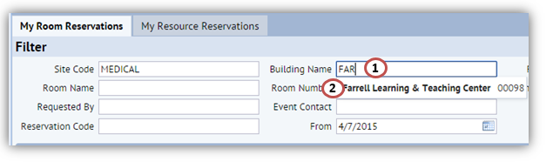
- Another way of choosing from a list of existing values is to type "?" in the field so that the system calls up the full set of values in a drop-down list. From this list, you can select a value. This method is similar to invoking the Select Values dialog but differs in that you are working directly in the grid field and so do not need to close the Select Values dialog box. Also, this method does not display descriptive text as does the Select Values dialog box.
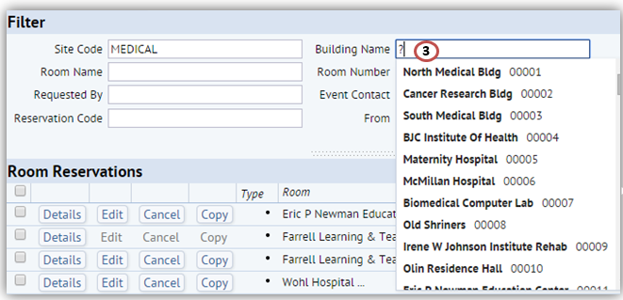

Sorting Data

Many Web Central screens present data in a tabular view. Column headers include a gray rectangle. Clicking this rectangle sorts the screen by that column.
- Click on the rectangle to sort the screen by this column’s data.
- The gray triangle indicates the order in which the data is sorted. A triangle pointing upwards indicates the data is sorted in ascending order. A triangle pointing downwards indicates the data is sorted in descending order.
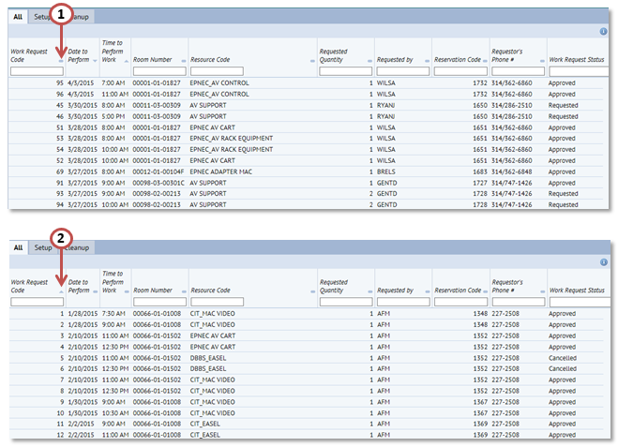

Using Filter Controls

If there is a large amount of data, you may want to restrict the information displayed. Many views offer a filter console in the top frame to filter data.
The filter console displays a series of fields enabling you to enter restriction criteria.
- Enter your restriction criteria.
- Click on the Show button to display data in the lower panel.
- If you do not want to enter a restriction, click Show without making any entries, and the data is presented without a restriction
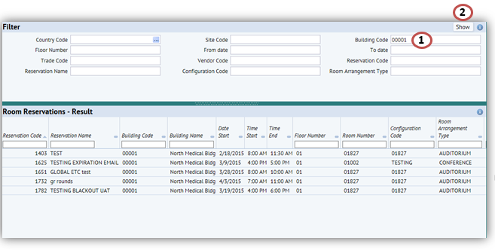

Restricting Data

Many views include a Smart Search feature that you can use to restrict the data shown in the view. The Smart Search feature uses a small filter console that enables you to restrict the view by entering values for any column header.
- Enter the restriction value in the Smart Search console field.
- If you want to find records that have particular characters anywhere within the value, enter those characters without a wildcard, such as “North" to find North Medical Building or BJHN-North Garage.
- To perform a wildcard search, use the "%" operator, such as entering “north%” to find values beginning with “North", such as, North Medical Building, but not BJHN-North Garage.
- Click on the Enter button on your keyboard.
- The records restricted to the value are displayed.
- To clear your entries, click on the Clear icon.
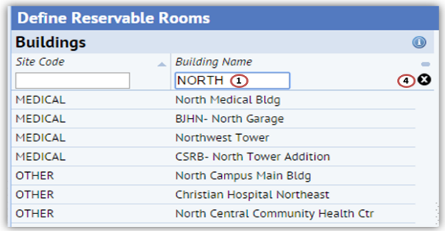

Restricting Data

Some Smart Searches with large data sets have an index bar to facilitate selecting data.
- Click on a letter or number in the index bar to view the records beginning with that letter or number.
- The number in parentheses shows how many employee names begin with that letter.
- “All” provides the number of records meeting your restriction or total number of records.
The index bar includes Prev (Previous) and Next links if there are more than the maximum number of records that meet the restriction.
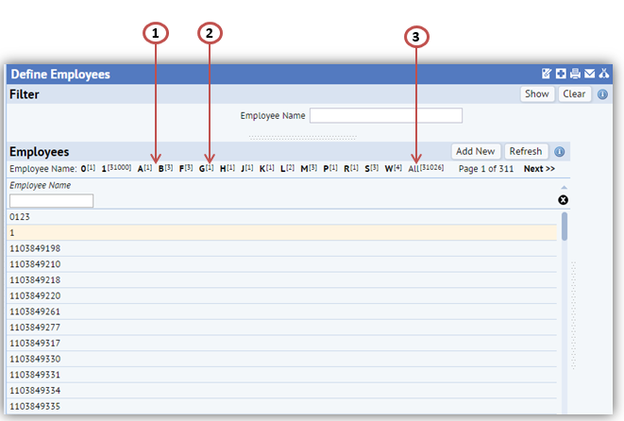

Using Drill Down Selection Lists

Some views include a drill-down selection list to help you quickly locate an item in a hierarchy similar to Microsoft Explorer, so that you can work with that item. You select items from the hierarchy (such as, Executive, Division and Section) that contain the item you want to work with. As you make selections, the list expands to show the items it contains.
- Click on the triangle-shaped button to expand an item in the hierarchy.
Some drill-down selection lists enable you to select check boxes for multiple items, and then click a Show Selected button to display the items.
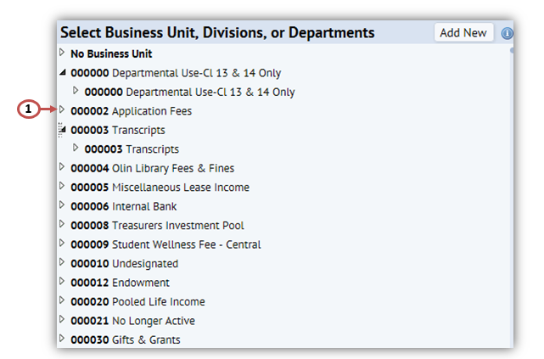

Background Information for Room Reservations

Help Text for Room Reservations

Selecting HELP will give you additional information about the application.

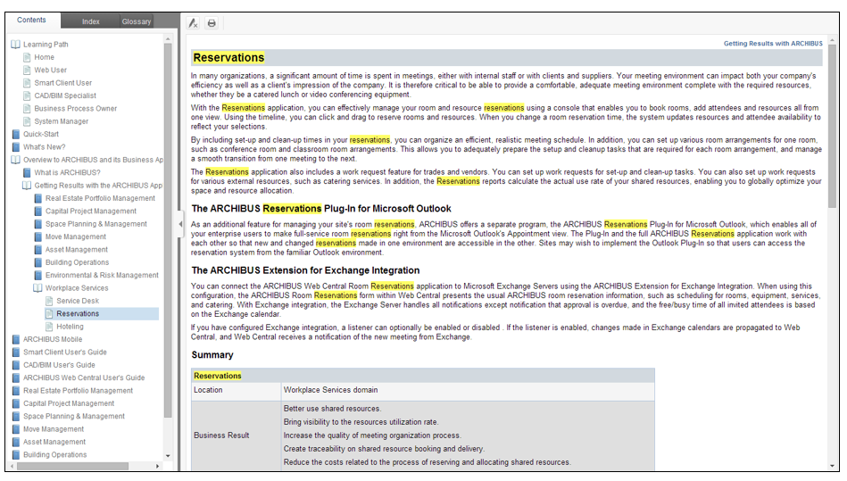

Reserving Rooms and/or Resources

Process Navigator for Creating Reservations

- Create New Room Reservation allows the user to create a reservation for a room as well as resources along with the room request.
- Create New Resource Reservation allows the user to create reservations for resources only.
- Create Multi-Room Reservation allows the user to create a reservation in multiple rooms at the same time.
- View and/or Edit my Reservations allows the user to review their current reservations.
- Verify My Room Reservation allows the user to verify they showed up for their reservation.
- Resolve My Reservation Conflicts allows the user to book alternate rooms for a recurring reservation, for which there was at least one instance where the selected room was not available.

Create a New Room Reservation

- Select a date from the calendar.
- Enter or select a Room Arrangement Type (the system defaults to DEFAULT).
- Enter the Capacity needed.
- To create a meeting recurrence, click on the Define Recurrence button.
- Enter a From Time (start).
- Enter an To Time (end).
- Select the Building for the reservation. Optionally, you can also select the floor and room if you are looking to reserve a particular room, or on a particular floor.
- To filter room availability based on a Fixed Resource, check the applicable box. Only three options are displayed. Click on the More button to view more options.
- Click Apply Filter to see which rooms fit your criteria. If a room does not show up, it means it is not available based on the search criteria.
- Click Clear Filter to clear the filter and set different parameters.
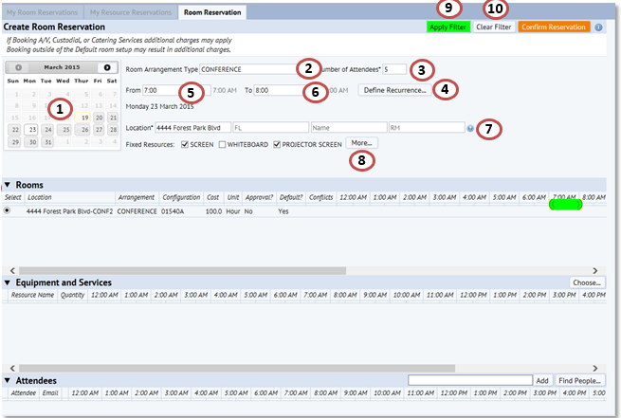

Create a New Room Reservation

- Click the room you want to reserve using the radio button and it will highlight the timeline in green.
- Click Choose under the Equipment and Services header to add a resource to your booking.
- On the popup Choose Equipment and Services view, select the equipment or service needed by entering the quantity.
- Click Select. The selected equipment item or services will appear on the Equipment and Services panel.
- After you’ve have selected all equipment items and services needed, click Close.
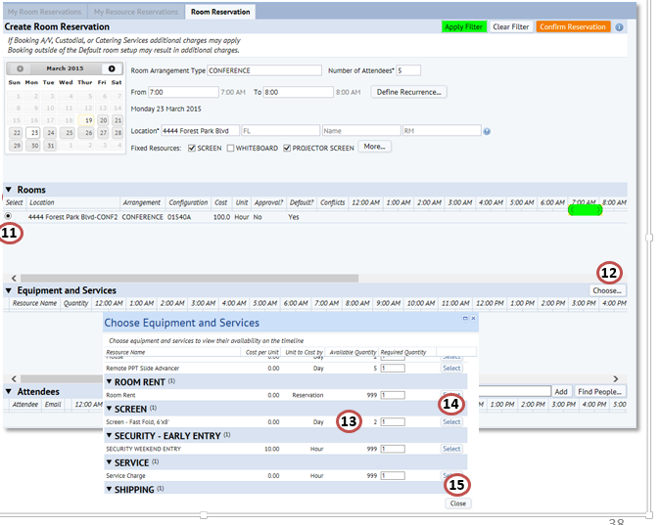

Create a New Room Reservation

To add Attendees to the reservation at this time within ARCHIBUS the user should:
- Search for an employee by using the smart filter. Enter a value, select an attendee from the list, then click Add.
- Or, click the Find People button to view a list of employees/visitors to select from. The selected attendee will appear on the Attendees panel.
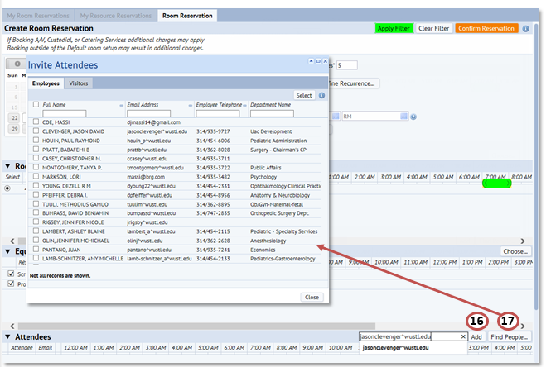

Create a New Room Reservation

- Click the Confirm Reservation button after the room, any resources, and attendees have been defined.
- The Confirm Reservation popup view is displayed. Select an Event Contact for the meeting/event.
- Enter an Event Name.
- Select an Event Type.
- Select whether your event will have food or beverages.
- Enter the Description of the event, if applicable.
- Populate the Bill To Department if the department paying for the reservation is different from that assigned to the user.
- Click Submit.
- Or, select Return to reservation form to continue editing your request.
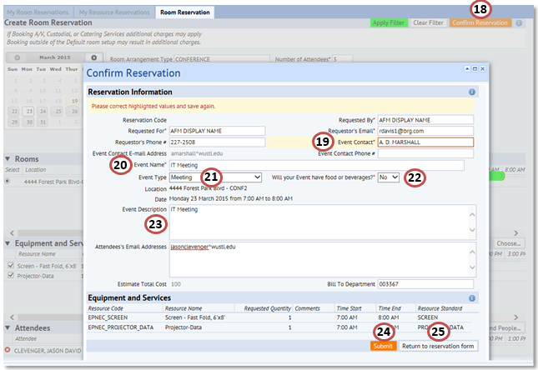

Create a New Resource Reservation

- Select a date from the calendar.
- Enter a From Time (start).
- Enter a To Time (end).
- To create a meeting recurrence, click on the Define Recurrence button.
- Select the Building room number for the reservation.
- Click Apply Filter to see which rooms fit your criteria.
- Click Clear Filter to clear the filter and set different parameters.
- Click Choose under the Equipment and Services header.
- On the popup Choose Equipment and Services view, select the equipment or service needed by entering the quantity.
- Click Select. The selected equipment item or services will appear on the Equipment and Services panel.
- After you’ve have selected all equipment items and services needed, click Close.

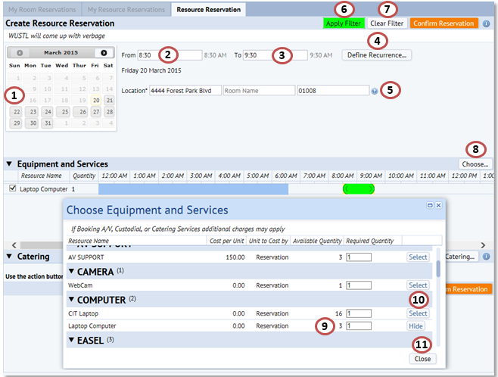

Create a New Resource Reservation

- Click the Confirm Reservation button.
- The Confirm Reservation popup view is displayed. Select an Event Contact and Event Contact Email Address if different from the requested by or logged in user.
- Enter an Event Name.
- Enter the Description of the event, if applicable.
- Update the Bill to Department if applicable.
- Click Submit.
- Or, select Return to reservation form to continue editing your request.
*Note: The Add Catering option is available and will generate an e-mail to the catering vendor. Two business days are required for catering requests to be processed and you can expect a call from the catering vendor. If you catering in less than 2 business days, please contact them by phone after entering your request in MyReservations.
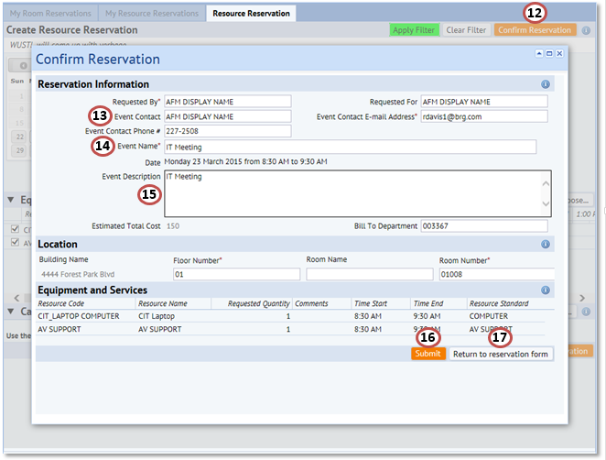

Create a Multi-Room Reservation

- Select a date from the calendar.
- Enter or select a Room Arrangement Type.
- Enter the Capacity needed.
- Enter a From Time (start).
- Enter a To Time (end).
- To create a meeting recurrence, click on the Define Recurrence button.
- Select the Building for the reservation. Optionally, you can also select up to four additional buildings to search for rooms.
- To filter room availability based on a Fixed Resource, check the applicable box. Only three options are displayed. Click on the More button to view more options.
- Click Apply Filter to see which rooms fit your criteria.
- Click Clear Filter to clear the filter and set different parameters.
*Note – For multi-room bookings resources must be added individually after submitting the booking.

Create a Multi-Room Reservation

- Click the rooms you want to reserve and it will highlight the timeline in green.
- You can search for an employee by using the smart filter. Enter a value, select an attendee from the list, then click Add.
- Or, click the Find People button to view a list of employees/visitors to select from. The selected attendee will appear on the Attendees panel.

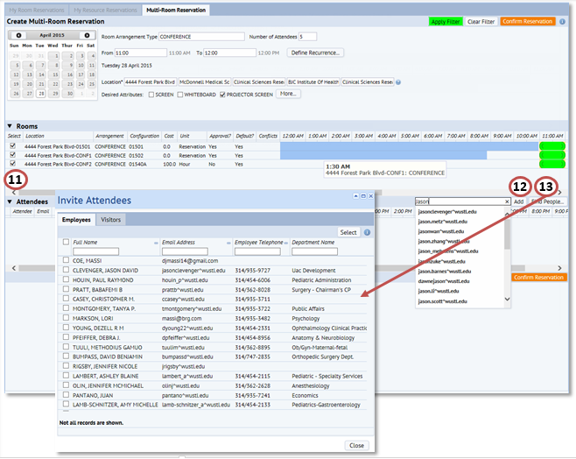

Create a Multi-Room Reservation

- Click the Confirm Reservation button.
- The Confirm Reservation popup view is displayed. Select an Event Contact.
- Enter an Event Name.
- Select an Event Type.
- Select whether your event will have food or beverages.
- Enter the Description of the event, if applicable.
- Update the Bill To Department as needed.
- Click Submit.
- Or, select Return to reservation form to continue editing your request.
NOTE: To add Resources you must do so within MyReservations for each reservation separately
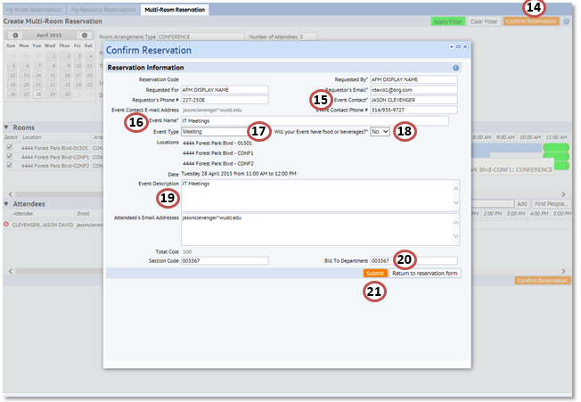

View and Edit My Reservations

- You can filter by any of the available fields in the Filter header and then click the Show button.
- Click Clear Filter to clear the filter and set different parameters.

The Room Reservations are listed with a few options.
- Click Details to view the reservation details of the reservation, including details about the room, request, etc.
- Click the Edit button to view and edit the reservation record.
- Click the Cancel button to cancel the meeting, a pop up window is displayed. Complete the Comments field as to why you are cancelling the reservation and click on the Confirm button.
- Click Copy to copy the parameters of this meeting (same room, invitees, resources) and pick a new reservation name and start date.
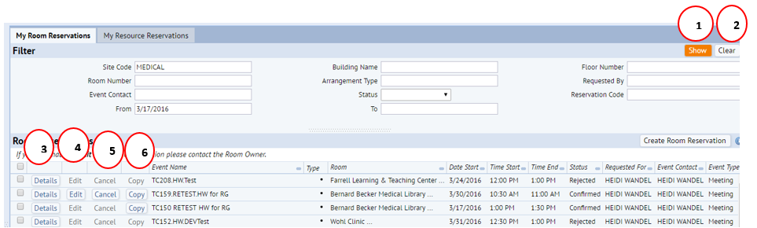

View and Edit My Reservations

- To cancel multiple reservations at one time, select the applicable reservation records and click the Cancel Selected button.
- Click the Create Room Reservation button to create a new reservation.
The user who requested the reservation or an Admin can come in and make changes or updates to the reservation up until its occurrence or based on other system settings.
- Click on the EDIT button in line with the reservation to be updated.
- The Edit Reservation view is launched with all the current attributes of the meeting populated in the filter.
- Update the filter panel as required and click APPLY FILTER or simply make the changes to the time of the meeting if available.
- Select the new room (if applicable) and add any new resources as needed.
- Click Confirm Reservation to submit the update.
*Note – If the reservation was in a CONFIRMED status and the location was changed to a room requiring approval, then the reservation status will be updated to Awaiting Approval.
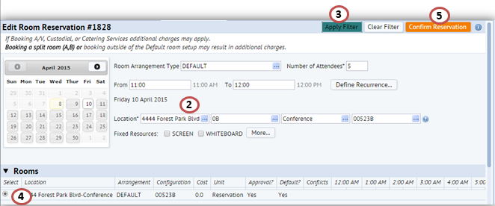

View and Edit My Reservations

You might want to verify a reservation requestor showed up, and the meeting actually occurred. This information can be used to improve occupancy statistics, and to determine if there are reservation requestors who frequently do not show up for their reservations.
- You can filter by any of the available fields in the Filter header and then click the Show button.
- Click Clear Filter to clear the filter and set different parameters.
- The Room Reservations are listed with a few options. Click Details to view the reservation record only.
- Click Verify at the beginning of the meeting to confirm meeting room is being used.
*Note – Reservations for the user only show up 30 minutes prior to their occurrence and remain on this screen until 30 minutes post event.

Resolve My Reservation Conflicts

The Resolve My Reservation Conflicts task is used to view your reservation conflicts and to resolve them, if needed.
- You can filter by any of the available fields in the Filter header and then click the Show button.
- Click Clear Filter to clear the filter and set different parameters.
- The Room Reservations are listed with a few options. Click Details to view the reservation record only.
- Click the Resolve Conflict button to resolve the conflict.
- Click the Cancel button to cancel the meeting, a pop up window is displayed. Complete the Comments field as to why you are cancelling the reservation and click on the Confirm button.

Calendar View – Read Only

The Calendar View gives users the ability to see all rooms and the current reservations, or gaps in reservations within them to better plan their meetings.
- You can filter by any of the available fields in the Filter header and then click the Apply Filter button.
- Click Clear Filter to clear the filter and set different parameters.
- The Room Arrangements are listed and reservations are shown in either GREEN (CONFIRMED) or RED (Awaiting Approval).
- Double Click on a Reservation to see the details.
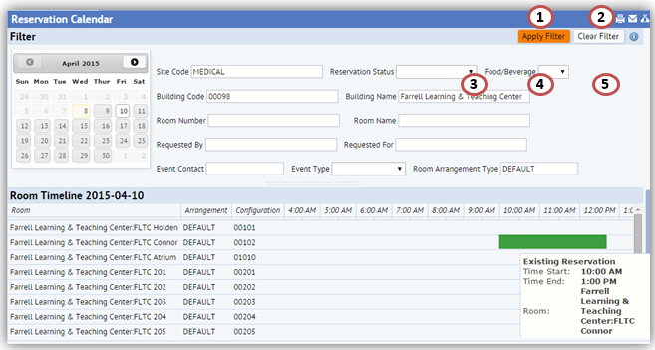
Manage Reservations

Process Navigator for Managing Reservations

- Create New Room Reservation allows the user to create a reservation for a room as well as resources along with the room request.
- Create New Resource Reservation allows the user to create reservations for resources only.
- Create Multi-Room Reservation allows the user to create a reservation in multiple rooms at the same time.
- View and/or Edit my Reservations allows the user to review their current reservations.
- Verify My Room Reservation allows the user to verify they showed up for their reservation.
- Resolve My Reservation Conflicts allows the user to book alternate rooms for a recurring reservations.
- Calendar View gives a snapshot of room usage and allows the user to make changes.

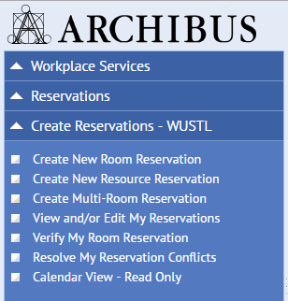

Verify a Room Reservation

You might want to verify a reservation requestor showed up, and the meeting actually occurred. This information can be used to improve occupancy statistics, and to determine if there are reservation requestors who frequently do not show up for their reservations.
- You can filter by any of the available fields in the Filter header and then click the Show button.
- Click Clear Filter to clear the filter and set different parameters.
- The Room Reservations are listed with a few options. Click Details to view the reservation record only.
- Click Verify at the beginning of the meeting to confirm meeting room is being used.
*Note – Reservations for the user only show up 30 minutes prior to their occurrence and remain on this screen until 30 minutes post event.
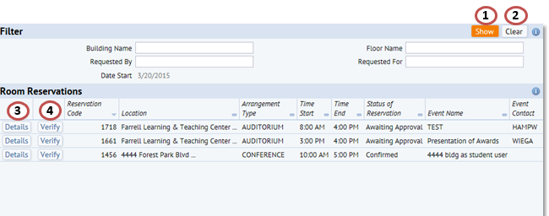

Resolve My Reservation Conflicts

The Resolve My Reservation Conflicts task is used to view your reservation conflicts and to resolve them, if needed.
- You can filter by any of the available fields in the Filter header and then click the Show button.
- Click Clear Filter to clear the filter and set different parameters.
- The Room Reservations are listed with a few options. Click Details to view the reservation record only.
- Click the Resolve Conflict button to resolve the conflict.
- Click the Cancel button to cancel the meeting, a pop up window is displayed. Complete the Comments field as to why you are cancelling the reservation and click on the Confirm button.

